# Spring Core and Maven

## Exercise 1: Configuring a Basic Spring Application

### CODE

**BookRepository.java**

package com.library.repository;

public class BookRepository {

public String findBookById(String id) {

return "Found book with ID: " + id;

}

}

**BookService.java**

package com.library.service;

import com.library.repository.BookRepository;

public class BookService {

private BookRepository bookRepository;

public void setBookRepository(BookRepository bookRepository) {

this.bookRepository = bookRepository;

}

public String getBookDetails(String bookId) {

return bookRepository.findBookById(bookId);

}

}

**LibraryApp.java**

package com.library.main;

import org.springframework.context.support.ClassPathXmlApplicationContext;

import com.library.service.BookService;

public class LibraryApp {

public static void main(String[] args) {

ClassPathXmlApplicationContext context = null;

try {

context = new ClassPathXmlApplicationContext("applicationContext.xml");

BookService service = context.getBean("bookService", BookService.class);

System.out.println("RESULT: " + service.getBookDetails("LIB-101"));

} finally {

if (context != null) {

context.close();

}

}

}

}

**applicationContext.xml**

<?xml version="1.0" encoding="UTF-8"?>

<beans xmlns="http://www.springframework.org/schema/beans"

xmlns:xsi="http://www.w3.org/2001/XMLSchema-instance"

xsi:schemaLocation="http://www.springframework.org/schema/beans

http://www.springframework.org/schema/beans/spring-beans.xsd">

<bean id="bookRepository" class="com.library.repository.BookRepository"/>

<bean id="bookService" class="com.library.service.BookService">

<property name="bookRepository" ref="bookRepository"/>

</bean>

</beans>

**pom.xml**

<project xmlns="http://maven.apache.org/POM/4.0.0"

xmlns:xsi="http://www.w3.org/2001/XMLSchema-instance"

xsi:schemaLocation="http://maven.apache.org/POM/4.0.0

https://maven.apache.org/xsd/maven-4.0.0.xsd">

<modelVersion>4.0.0</modelVersion>

<groupId>com.library</groupId>

<artifactId>LibraryManagement</artifactId>

<version>1.0</version>

<name>LibraryManagement</name>

<properties>

<spring.version>5.3.20</spring.version>

<junit.version>4.13.2</junit.version>

<java.version>1.8</java.version>

</properties>

<dependencies>

<dependency>

<groupId>org.springframework</groupId>

<artifactId>spring-context</artifactId>

<version>${spring.version}</version>

</dependency>

<dependency>

<groupId>org.slf4j</groupId>

<artifactId>slf4j-api</artifactId>

<version>1.7.36</version>

</dependency>

<dependency>

<groupId>ch.qos.logback</groupId>

<artifactId>logback-classic</artifactId>

<version>1.2.11</version>

</dependency>

<dependency>

<groupId>junit</groupId>

<artifactId>junit</artifactId>

<version>${junit.version}</version>

<scope>test</scope>

</dependency>

</dependencies>

<build>

<plugins>

<plugin>

<groupId>org.apache.maven.plugins</groupId>

<artifactId>maven-compiler-plugin</artifactId>

<version>3.8.1</version>

<configuration>

<source>${java.version}</source>

<target>${java.version}</target>

</configuration>

</plugin>

</plugins>

</build>

<profiles>

<profile>

<id>allow-java-24</id>

<activation>

<jdk>24</jdk>

</activation>

<properties>

<maven.compiler.release>17</maven.compiler.release>

</properties>

</profile>

</profiles>

</project>

### OUTPUT

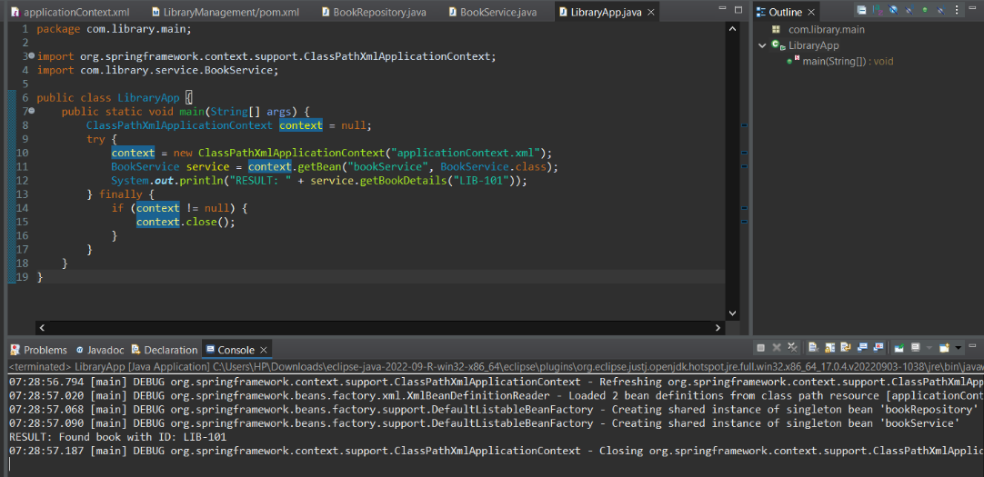

## Exercise 2: Implementing Dependency Injection

### CODE

**BookRepository.java**

package com.library.repository;

public class BookRepository {

public void saveBook(String bookTitle) {

System.out.println("Saving book to database: " + bookTitle);

}

}

**BookService.java**

package com.library.service;

import com.library.repository.BookRepository;

public class BookService {

private BookRepository bookRepository;

public void setBookRepository(BookRepository bookRepository) {

this.bookRepository = bookRepository;

}

public void addBook(String bookTitle) {

bookRepository.saveBook(bookTitle);

}

}

**LibraryManagementApplication.java**

package com.library;

import org.springframework.context.ApplicationContext;

import org.springframework.context.support.ClassPathXmlApplicationContext;

import com.library.service.BookService;

public class LibraryManagementApplication {

public static void main(String[] args) {

try {

ApplicationContext context = new ClassPathXmlApplicationContext("classpath:applicationContext.xml");

BookService bookService = context.getBean("bookService", BookService.class);

bookService.addBook("Spring in Action");

bookService.addBook("Clean Code");

System.out.println("Dependency injection with Maven works!");

} catch (Exception e) {

System.err.println("Error initializing Spring context: " + e.getMessage());

e.printStackTrace();

}

}

}

**applicationContext.xml**

<?xml version="1.0" encoding="UTF-8"?>

<beans xmlns="http://www.springframework.org/schema/beans"

xmlns:xsi="http://www.w3.org/2001/XMLSchema-instance"

xsi:schemaLocation="http://www.springframework.org/schema/beans

http://www.springframework.org/schema/beans/spring-beans.xsd">

<bean id="bookRepository" class="com.library.repository.BookRepository" />

<bean id="bookService" class="com.library.service.BookService">

<property name="bookRepository" ref="bookRepository" />

</bean>

</beans>

**pom.xml**

<project xmlns="http://maven.apache.org/POM/4.0.0"

xmlns:xsi="http://www.w3.org/2001/XMLSchema-instance"

xsi:schemaLocation="http://maven.apache.org/POM/4.0.0

http://maven.apache.org/xsd/maven-4.0.0.xsd">

<modelVersion>4.0.0</modelVersion>

<groupId>com.library</groupId>

<artifactId>library-management</artifactId>

<version>1.0-SNAPSHOT</version>

<properties>

<spring.version>5.3.20</spring.version>

</properties>

<dependencies>

<!-- Spring Core Essentials -->

<dependency>

<groupId>org.springframework</groupId>

<artifactId>spring-core</artifactId>

<version>5.3.20</version>

</dependency>

<dependency>

<groupId>org.springframework</groupId>

<artifactId>spring-beans</artifactId>

<version>5.3.20</version>

</dependency>

<dependency>

<groupId>org.springframework</groupId>

<artifactId>spring-context</artifactId>

<version>5.3.20</version>

</dependency>

<dependency>

<groupId>org.springframework</groupId>

<artifactId>spring-expression</artifactId>

<version>5.3.20</version>

</dependency>

</dependencies>

<build>

<plugins>

<plugin>

<groupId>org.apache.maven.plugins</groupId>

<artifactId>maven-compiler-plugin</artifactId>

<version>3.8.1</version>

<configuration>

<source>1.8</source>

<target>1.8</target>

</configuration>

</plugin>

</plugins>

</build>

</project>

### OUTPUT

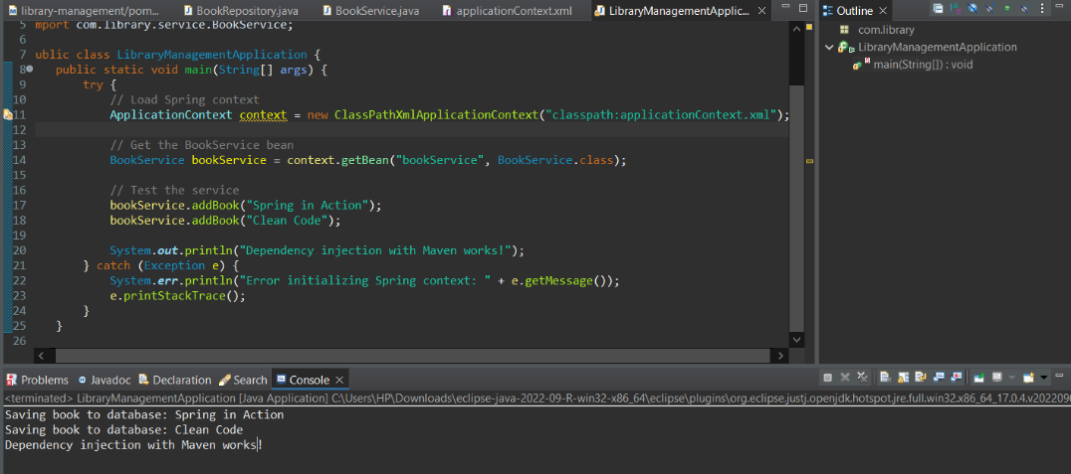

## Exercise 4: Creating and Configuring a Maven Project

**App.java**

package com.example.main;

import org.springframework.context.ApplicationContext;

import org.springframework.context.annotation.AnnotationConfigApplicationContext;

import org.springframework.context.annotation.ComponentScan;

import org.springframework.context.annotation.Configuration;

@Configuration

@ComponentScan

public class App {

public static void main(String[] args) {

ApplicationContext context = new AnnotationConfigApplicationContext(App.class);

System.out.println("Spring context initialized successfully!");

}

}

**pom.xml**

<project xmlns="http://maven.apache.org/POM/4.0.0"

xmlns:xsi="http://www.w3.org/2001/XMLSchema-instance"

xsi:schemaLocation="http://maven.apache.org/POM/4.0.0 https://maven.apache.org/xsd/maven-4.0.0.xsd">

<modelVersion>4.0.0</modelVersion>

<groupId>com.example</groupId>

<artifactId>MavenProject</artifactId>

<version>1.0.0</version>

<name>Maven_Project</name>

<properties>

<project.build.sourceEncoding>UTF-8</project.build.sourceEncoding>

<maven.compiler.source>1.8</maven.compiler.source>

<maven.compiler.target>1.8</maven.compiler.target>

<spring.version>5.3.20</spring.version>

</properties>

<dependencies>

<!-- Spring Context -->

<dependency>

<groupId>org.springframework</groupId>

<artifactId>spring-context</artifactId>

<version>${spring.version}</version>

</dependency>

<!-- Spring AOP -->

<dependency>

<groupId>org.springframework</groupId>

<artifactId>spring-aop</artifactId>

<version>${spring.version}</version>

</dependency>

<!-- Spring Web MVC -->

<dependency>

<groupId>org.springframework</groupId>

<artifactId>spring-webmvc</artifactId>

<version>${spring.version}</version>

</dependency>

</dependencies>

<build>

<plugins>

<plugin>

<groupId>org.apache.maven.plugins</groupId>

<artifactId>maven-compiler-plugin</artifactId>

<version>3.8.1</version>

<configuration>

<source>1.8</source>

<target>1.8</target>

</configuration>

</plugin>

</plugins>

</build>

</project>

### OUTPUT

